Record Note of Annual Performance Review of NESCO Utility held on 27.05.2019 at 11.00AM in the Training Hall of the OERC in the presence of the Commission

Date of Review : 27th May, 2019
Period of Review : April 2018-March 2019
Representatives of NESCO Utility: list enclosed as Annexure-I.
The performance of NESCO Utility for FY 2018-19 was reviewed by the Commission on 27th May, 2019 at 11.00 AM in the presence of senior officials of NESCO Utility. The Commission reviewed the billing and collection position of the NESCO Utility for the period from April 2018 to March 2019.
The details of performance of NESCO Utility as indicated in their presentation with regard to the key performance indicators are as follows:-
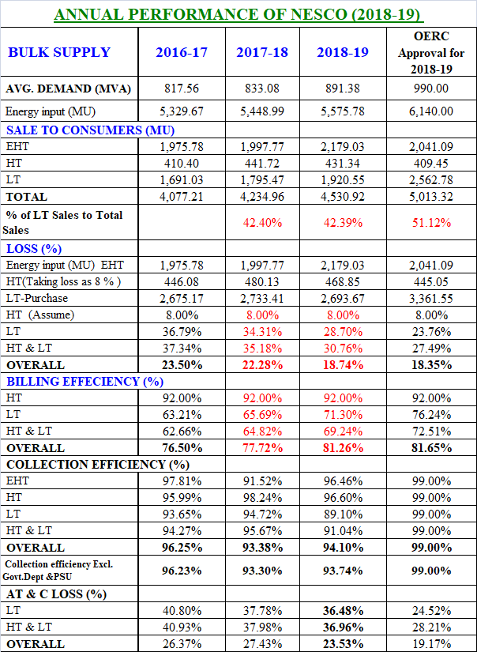

Commission’s Observations:
The Commission compared the figures relating to business operation of NESCO Utility for FY 2018-19 at for the corresponding period of FY 2017-18. The key observations are as follows:-
 | As on 31.03.2018 | As on 31.03.2019 | Increase / Decrease | (↑↓)
No of consumer | 15,19,426 | 19,63,316 | 443890 | ↑
No.of Working Meter | 11,83,756 | 12,95,050 | 211294 | ↑
EHT Sale (MU) | 1997.77 | 2179.03 | 181.26 | ↑
HT Sale (MU) | 441.72 | 431.34 | -10.38 | ↓
LT Sale (MU) | 1795.47 | 1920.55 | 125.08 | ↑
Distribution Loss | 22.28 % | 18.74% | -3.54 | ↓
Billing Efficiency | 77.72 % | 81.26 % | 3.54 | ↑
Collection Efficiency | 93.38 % | 94.10 % | 0.72 | ↑
AT & C Loss | 27.43 % | 23.53 % | -3.90 | ↓

- On enquiry about the number of exact number of consumer under billing fold, A.O., NESCO Utility told that after addition of 4,68,000 consumers in Saubhagya Scheme, now NESCO Utility has 19,63,316 consumers out of which 2,59,000 consumers are yet to be brought under billing fold.
- There is 181.26 MU increase in EHT sale whereas only 10.38 MU increase in HT sale. Though there is 4,68,000 consumers addition in Saubhagya, there is only 125.08MU increase in LT sale. Since 2,59,000 consumers yet to be brought under billing fold, the actual increase in LT sale is not reflected.
- On Energy Audit, NESCO Utility submitted that all 88 nos of 33 kV feeders are metered and out of 88 Nos. of 33 KV feeders 50 Nos. have been audited. Out of 674 nos of 11 kV feeders, 530 nos.of 11 kV meters are ok and out of which 474 nos are audited. Out of 62545 nos of DTRs only 1662 nos. are metered and 396 nos. are audited.
- NESCO Utility has completed consumer tagging of 568 Nos. 11kV feeders and consumer tagging of balance 58 No.s 11kV feeders are in progress.
- NESCO has cleared all BSP bill till March 2019.
- There is 50% reduction in T & D loss of Sunahat feeder, from 71.9% to 22.3% which is commendable. There may not be much scope for further reduction in T&D loss in 4 pilot feeders i.e. Nathuabara, Agarpada, Seragarh and Naikudi, as assigned by the Commission. NESCO Utility may take up 5 more pilot feeders for energy audit.

Name of the Division | FY.2017-18 (Apr-Mar) | FY.2018-19 (Apr-Mar) | Increase / Decrease
BED, BALASORE | 12.58% | 16.14% | 3.56%
BTED, BASTA | 48.12% | 42.61% | -5.51%
JED, JALESWAR | 38.69% | 34.74% | -3.95%
CED, BALASORE | 49.46% | 49.54% | 0.08%
SED, SORO | 27.12% | 23.14% | -3.98%
BALASORE CIRCLE | 34.70% | 33.36% | -1.34%
BNED, BHADRAK | 39.83% | 35.51% | -4.32%
BSED, BHADRAK | 39.15% | 39.22% | 0.07%
BHADRAK CIRCLE | 39.81% | 36.77% | -3.04%
BPED, BARIPADA | 39.21% | 38.20% | -1.01%
UED, UDALA | 42.22% | 41.12% | -1.10%
RED, RAIRANGPUR | 47.45% | 49.78% | 2.33%
BARIPADA CIRCLE | 42.39% | 42.45% | 0.06%
JRED, JAJPUR ROAD | 37.00% | 36.54% | -0.46%
JTED, JAJPUR TOWN | 46.42% | 46.96% | 0.54%
KUED, KUAKHIA | 49.66% | 50.53% | 0.87%
JAJPUR CIRCLE | 44.00% | 44.21% | 0.21%
KED, KEONJHAR | 15.67% | 13.11% | -2.56%
JOED, JODA | 13.80% | 12.52% | -1.28%
AED, ANANDPUR | 36.36% | 28.42% | -7.94%
KEONJHAR CIRCLE | 23.48% | 19.28% | -4.20%
NESCO AS WHOLE | 37.78% | 36.48% | -1.30%

- It is observed from the LT AT& C loss table above that Anandpur Division has performed best among all divisions and BED, Balasore has performed worst with 3.56% increase in LT AT & C loss.
- Commission enquired about reduction in collection efficiency from the level of last year. It is observed from the KPI data that though billing has been made for 95% of the total consumer, money receipt is only 40% of the bill generated.

10. 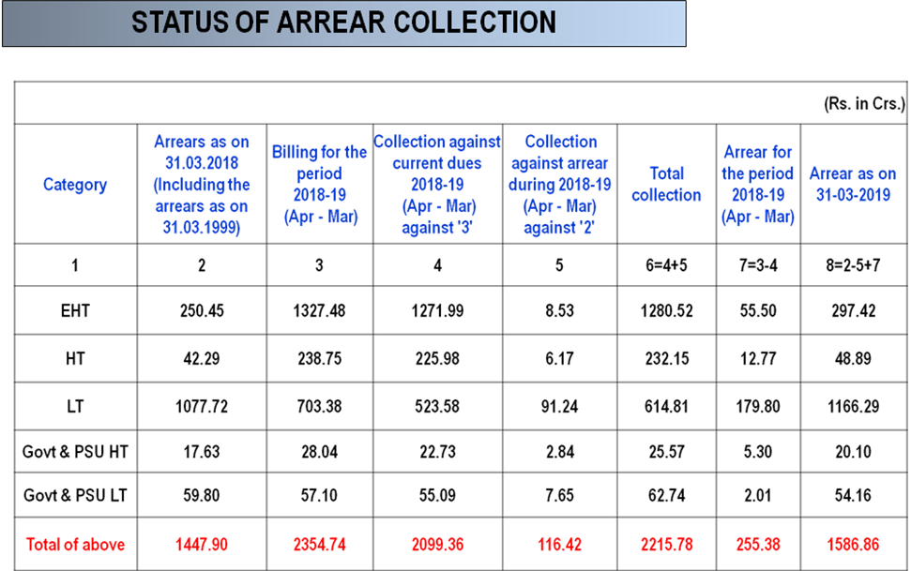
It is observed that there is 139Cr. increase in arrear in FY 2018-19. Commission advised NESCO Utility to collect the same and utilise it in R&M.
- Metering Status:-
Report on Metering
Sl. No. | Particulars | NESCO Utility
 |  | As on 31.03.2018 | As on 30.03.2019
 | SINGLE PHASE
1 | Total Number of Consumer | 14,77,282 | 16,71,150
2 | Number of consumers without meters | 20,233 | 1,20,311
3 | Number of defective meters | 3,06,061 | 2,90,388
4 | Number of Meters in Working condition | 11,50,988 | 12,60,451
5 | Number of Static Meters | 11,12,481 | 12,27,510
6 | Number of electro-mechanical Meters | 38,507 | 32,941
 | THREE PHASE
1 | Total Number of Consumer | 42,144 | 45,274
2 | Number of consumers without meters | 4,315 | 5,333
3 | Number of defective meters | 5,061 | 5,342
4 | Number of Meters in Working condition | 32,768 | 34,599
5 | Number of Static Meters | 32,517 | 34,369
6 | Number of electro-mechanical Meters | 251 | 230
 | Total number of consumers | 15,19,426 | 17,16,424
 | Consumers added in Saubhagya (Not included in billing fold) |  | 2,46,892
 | Total number of consumers | 15,19,426 | 19,63,316
Out of 5,40,000 meters of NESCO Utility to be installed by GRIDCO, 2,15,000 meters are already installed and rest will be installed by October 2019. 1,50,000 meters will be procured by NESCO Utility and will be installed by December 2019. If possible, these meters for NESCO utility may be procured in IPDS/DDUGJY or any other scheme of the Government. NESCO Utility must install @ 25,000 meters per month starting from July, 2019 so as to complete the installation of 1,50,000 meters by December,2019. Monthly report in this regard must be submitted by NESCo Utility.
- Smart metering is to be done in areas with high AT & C loss and good network connectivity.
- The Commission observed that at places such as Bisoi, Kusumi and Marada SHGs have not come forward for taking up MBC work on outsourcing mode. It is felt that local JE might not have motivated the local SHGs for taking up this work. A.O. NESCO Utility assured that he would take up the work immediately.
- Commission enquired about poor energy audit in 33kV though metering is 100% in 33kV.
- It is observed that number of cases finalized under section 126 & 135 have reduced much compared to last year.
Directives of the Commission:

- It is observed from Annual performance Review 18-19 that NESCO has performed best among 4 DISCOMs reducing AT & C loss from 27.43% to 23.53%.
- Commission asked A.O., NESCO Utility to increase the Collection efficiency and take action against poor performing divisions.
- Commission directed NESCO to submit report on installation of 30,000 AMR procured and to prepare a month wise plan of the same and submit within a week.
- NESCO utility should concentrate on performance improvement of Balasore division whose performance has deteriorated.
- Commission directed NESCO utility to complete all the consumer metering within 6 months. Monthly progress report of the same should be sent to Commission. Some officers from OERC should go and check the type of meters supplied by RGGVY and other such schemes.
- Commission directed NESCO Utility to submit correct AMR metering data.
- NESCO Utility has not yet submitted the 5year business plan. This must be submitted by 30.06.2019.

****
Annexure-1
Representative of NESCO

- Sri Shankar Krishnan, A.O., NESCO
- Sri S.P.Mallick, COO
- Sri P.M.Mohanty, Sr.G.M.(F)
- Sri S. K. Dash, G.M.(Project)
- Sri S C Mahalik , GM (Operation)
- Sri A. K. Sahu
- Sri Malancha Ghose, AGM(RA)
- Sri Sanjib Kr.Jena, Manager(Elect)
- Sri G.S.Mohapatra, Manager(F)
- Sri A.K.Mohapatra, Manager(F)

