ODISHA ELECTRICITY REGULATORY COMMISSION

PLOT NO. 4, CHUNOKOLI,SAILASHREE VIHAR

BHUBANESWAR - 751 021
************

No.DIR (T)-368/09/18/

Dated- .07.2020

To
The Authorised Officer ,
NESCO Utility, At/P.O. Januganj,
Dist. Balasore.

Sub: Review of Annual Performance of NESCO Utility FY 2019-20 (April-March)

Sir,
In inviting a reference to the subject cited above, I am directed to send herewith the aforesaid report for your information and necessary action.

Yours faithfully,

Encl: As above.

SECRETARY

Copy to:
- The Principal Secretary, Department of Energy, Govt. of Odisha along with copy of the enclosure for favour of information.
- The MD, OPTCL, Janpath, Bhubaneswar along with copy of the enclosure for favour of information.

Encl: As above.

SECRETARY

Record Note of Annual Performance Review of NECSO Utility held on 26.06.2020 at 11:00AM through video-conferencing in the presence of the Commission

Date of Review : 26th June, 2020
Period of Review : April 2019-March 2020
Representatives of NESCO : list enclosed as Annexure-I.
The performance of NESCO utility for FY 2019-20 was reviewed by the Commission on 26th June, 2020 at 11:00 AM through video conferencing, keeping in view the current pandemic (Covid-19) situation. The senior officials of NESCO utility were present during the review.
The details of performance of NESCO utility as indicated in their presentation with regard to the key performance indicators are as follows:-
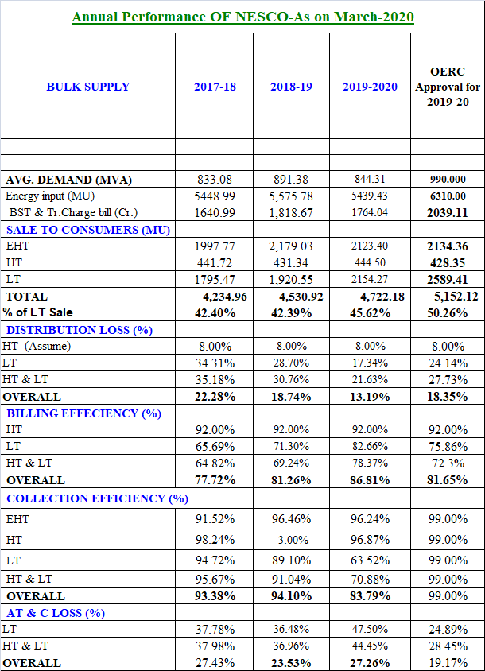

Commission’s Observations:
The. AO, NESCO Utility apprised the Commission about the performance made by NESCO Utility during FY 2019-20.
The Commission compared the figures relating to business operation of NESCO Utility for FY 2019-20 with that of FY 2018-19. The key observations are as follows:-
 | As on 31.03.2019 | As on 31.03.2020 | Increase / Decrease | (↑↓)
EHT Sale (MU) | 2179.03 | 2123.40 | 55.63 | ↓
HT Sale (MU) | 431.34 | 444.50 | 12.16 | ↑
LT Sale (MU) | 1920.55 | 2154.27 | 233.72 | ↑
Distribution Loss | 18.74% | 13.19% | 4.45% | ↓
Billing Efficiency | 81.26% | 86.81% | 5.55% | ↑
Collection Efficiency | 94.10% | 83.79% | 10.31% | ↓
AT & C Loss | 23.53% | 27.26% | 3.73% | ↑

- From the above table it is observed that there is decrease of EHT sale of 55.63 MU, where as in HT & LT category the sale has increased by 12.16MU & 233.72MU respectively.
- NESCO utility submitted that 1,90,132 number of consumers have been added during the FY 2019-20.The total number of consumers as on 31.03.2020 is 19,63,316, out of which 19,32,556 number of consumers are given service connection. Total 19,06,556 nos. consumers are under billing fold of NESCO Utility.
- On Energy Audit, NESCO utility submitted that out of 91 nos. of 33 kV feeders, all 91 feeders are metered and 63 Nos. have been audited. Out of 696 nos. of 11 kV feeders all 696 nos. of 11 kV feeders have been metered. They have audited 510 nos. 11 kV feeders. Out of 64562 nos. of DTRs, 1864 DTRs are metered and 52242 numbers of DTRs are audited.
- NESCO utility had paid BSP up to April 2020, i.e. it is lagging behind 1 month in BSP payment.

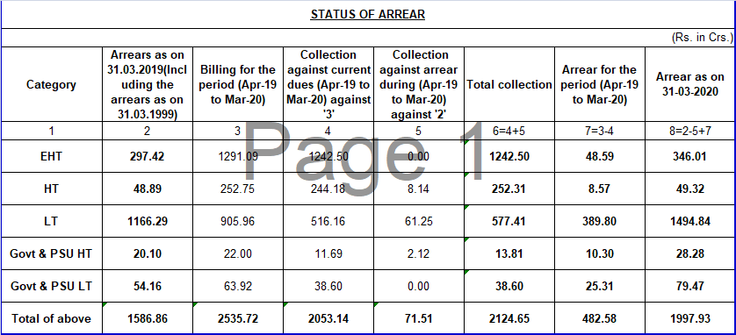

- Metering Status:-
The Commission reviewed the progress in consumer metering. The representatives of PMU, OPTCL stated that out of 5,40,000 meters to be supplied by them, 4,97,000 meters are already installed in NESCO utility area and only 43,000 meters are left to be installed. OPTCL has procured additional 87,000 meters for NESCO Utility and will install the same. On enquiry about what Provision NESCO Utility has to install rest 1,50,000 meters, NESCO officials told that presently they have 59,000 meters with them including 21,000 meters from PGCIL. For rest 80,000 meters required, they do not have any provision of funding.
According to officials of NESCO 1,16,424 meters which were actually OK meters were replace by M/S. Linkwell.
- Commission enquired about the negative T & D loss in Udala, Keonjhar and Joda division and asked about the action has been taken by A.O.. In reply to this NESCO official told that the billing of Keonjhar division was stopped till December 2019 and provisional billing had been done for the same period. He asked for 15 days time to correct the same.
- Commission expressed displeasure over the reduction in collection efficiency and increase in AT & C loss compared to previous year. The reduction in Collection efficiency is due to arrear from EHT consumers like Balasore alloy,and Rohit ferro Alloys which includes 25 Cr. From Balasore Alloys and 31Cr. From Rohit Ferro Alloys. NESCO has disconnected power supply to Balasore Alloys for this.

Directives of the Commission:

- Commission directed NESCO Utility to complete 11 kV feeder metering by September 2020.
- The Commission directed A.O., NESCO Utility to find out those who are responsible for replacement of 1,16,424 numbers of OK meters in NESCO Utility and take action against the person concerned.
- The Commission directed S.E., Bhadrak to submit the reason behind high T&D loss in Bhadrak.
- The Commission directed NESCO Utility to adopt both Billing & Collection figure of month of April of previous year to March of succeeding year for computation of Billing & Collection efficiency of a financial year. They are directed to recalculate the same for FY 2019-20 and furnish this office.
****

