ODISHA ELECTRICITY REGULATORY COMMISSION

PLOT NO. 4, CHUNOKOLI,SAILASHREE VIHAR

BHUBANESWAR - 751 021
************

No.DIR (T)-368/09/18/

Dated- .08.2020

To
The Authorised Officer,
SOUTHCO Utility, At/P.O. Courtpeta,
Berhampur, Dist. Ganjam.
.

Sub: Review of Annual Performance of SOUTHCO Utility FY 2019-20 (April-March)

Sir,
In inviting a reference to the subject cited above, I am directed to send herewith the aforesaid report for your information and necessary action.

Yours faithfully,

Encl: As above.

SECRETARY

Copy to:
- The Principal Secretary, Department of Energy, Govt. of Odisha along with copy of the enclosure for favour of information.
- The MD, OPTCL, Janpath, Bhubaneswar along with copy of the enclosure for favour of information.

Encl: As above.

SECRETARY

Record Note of Annual Performance Review of SOUTHCO Utility held on 03.07.2020 at 11:00AM through video-conferencing in the presence of the Commission

Date of Review : 03rd July, 2020
Period of Review : April 2019-March 2020
Representatives of SOUTHCO : list enclosed as Annexure-I.
The performance of SOUTHCO Utility for FY 2019-20 was reviewed by the Commission on 03rd July, 2020 at 11:00 AM through video conferencing, keeping in view the current pandemic (Covid-19) situation. The senior officials of SOUTHCO Utility were present during the review.
The details of performance of SOUTHCO Utility as indicated in their presentation with regard to the key performance indicators are as follows:-
ANNUAL PERFORMANCE OF SOUTHCO(2019-2020)
BULK SUPPLY | 2017-18 | 2018-19 | 2019-20 | OERC Approval for 2019-20
AVG. DEMAND (MVA) | 588.00 | 634.18 | 613.86 | 660.00
Energy input (MU) | 3468.00 | 3638.95 | 3468.63 | 4040.00
BST & Tr.Charge bill (Cr.) | 777.00 | 808.28 | 739.88 | 853.07
Payment made to GRIDCO (Cr.)
% payment
BST bill P/U | 224.05 | 222.12 | 213.30 | 211.16
SALE TO CONSUMERS (MU)
EHT | 399.00 | 456.02 | 488.52 | 406.25
HT | 209.00 | 285.30 | 269.74 | 312.62
LT | 1726.00 | 1814.56 | 1861.71 | 2290.93
TOTAL | 2,334.00 | 2,555.88 | 2,619.97 | 3,009.80
% of LT Sales to Total Sales | 73.95% | 71.00% | 71.06% | 76.12%
LOSS (%)
HT (Assume) | 8.00% | 8.00% | 8.00% | 8.00%
LT | 33.98% | 31.34% | 24.69% | 24.40%
HT & LT | 36.95% | 34.03% | 28.48% | 28.35%
OVERALL | 32.70% | 29.76% | 24.47% | 25.50%
BILLING EFFECIENCY (%)
HT | 92.0% | 92.0% | 92.0% | 92.0%
LT | 66.0% | 68.7% | 75.3% | 75.6%
HT & LT | 63.0% | 66.0% | 71.5% | 71.6%
OVERALL | 67.3% | 70.2% | 75.5% | 74.5%
COLLECTION EFFICIENCY (%)
EHT | 100% | 100% | 100% | 99%
HT | 98% | 94% | 91% | 99%
LT | 87% | 81% | 77% | 99%
HT & LT | 89% | 83% | 80% | 99%
OVERALL | 91.42% | 86.95% | 84.34% | 99.00%
AT & C LOSS (%)
LT | 42.34% | 44.70% | 42.02% | 25.16%
HT & LT | 43.88% | 45.18% | 43.06% | 29.07%
OVERALL AT & C Loss | 38.48% | 38.93% | 36.29% | 26.25%

Commission’s Observations:
The. AO, SOUTHCO Utility apprised the Commission about the performance made by SOUTHCO Utility during FY 2019-20.
The Commission compared the figures relating to business operation of SOUTHCO Utility for FY 2019-20 with that of FY 2018-19. The key observations are as follows:-

 | As on 31.03.2019 | As on 31.03.2020 | Increase / Decrease | (↑↓)
EHT Sale (MU) | 456.02 | 488.52 | 32.32 | ↑
HT Sale (MU) | 285.30 | 269.74 | 15.56 | ↓
LT Sale (MU) | 1814.56 | 1861.71 | 47.15 | ↑
Distribution Loss | 29.76% | 24.47% | 5.29 | ↓
Billing Efficiency | 70.24% | 75.53% | 5.29 | ↑
Collection Efficiency | 86.95% | 84.34% | 2.61 | ↑
AT & C Loss | 38.93% | 36.29% | 2.64 | ↑

- From the above table it is observed that there is decrease in HT sale of 15.56 MU, where as in EHT & LT category the sale has increased by 32.32 MU & 47.15MU respectively.
- SOUTHCO Utility submitted that 2,10,517 number of consumers have been added during the FY 2019-20.The total number of consumers as on 31.03.2020 is 22,79,096 and all the consumers are under billing fold of SOUTHCO Utility.
- On Energy Audit, SOUTHCO utility submitted that out of 105 nos. of 33 kV feeders, 74 feeders are metered and 64 Nos. have been audited. Out of 695 nos. of 11 kV feeders, only 290 nos. of 11 kV feeders have been metered. They have audited 140 nos. 11 kV feeders. Out of 51925 nos. of DTRs, only 442 DTRs are metered and none of the DTRs are audited.
- SOUTHCO utility had paid BSP up to August 2019, i.e. it is lagging behind 8 months in BSP payment.

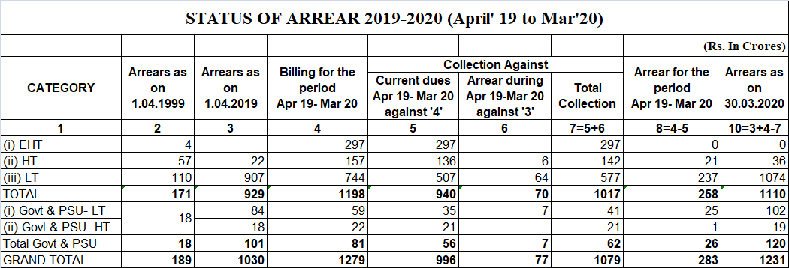

- Metering Status:-
The Commission reviewed the progress in consumer metering. The representatives of PMU, OPTCL stated that out of 9,31,974 meters in scope to be supplied by them 8,22,000 meters already supplied to SOUTHCO Utility. Out of 2,72,149 meters to be installed by them, 2,08,941 meters will be installed by OPTCL and 63,208 meters will be installed by SOUTHCO Utility. On Commission’s enquiry about shortfall of 1,50,00 meters in SOUTHCO Utility, representatives of PMU, OPTCL told they can supply1,08,000 meters for which SOUTHCO Utility will give requisition.
- Commission appraised the performance of SOUTHCO utility over the reduction in both distribution loss and AT & C loss compared to previous year. On enquiry about increase in both billing efficiency and billing amount, A.O. SOUTHCO utility stated that it is possible due to increase in EHT sale and by bringing Saubhagya consumers under billing fold.
- It is observed that Jeypore circle has performed really well reducing AT & C loss by 7%.
- SOUTHCO Utility has also reduced both number of DTR burnt and capacity of burnt DTR compared to previous year.

Directives of the Commission:

- Commission directed SOUTHCO Utility to complete all 33 kV & 11 kV feeder metering first.
- The Commission directed A.O., SOUTHCO Utility to give requisition letter to PMU, OPTCL to supply them more meters.
- The Commission directed SOUTHCO to complete consumer metering as soon as possible.
****

