ODISHA ELECTRICITY REGULATORY COMMISSION

PLOT NO. 4, CHUNOKOLI,SAILASHREE VIHAR

BHUBANESWAR - 751 021
************

No.DIR (T)-368/09/18/

Dated- .08.2020

To
The Chief Executive Officer,
CESU, 2nd Floor, IDCO Tower
Janpath, Bhubaneswar

Sub: Review of Annual Performance of TPCODL FY 2019-20 (April-March)

Sir,
In inviting a reference to the subject cited above, I am directed to send herewith the aforesaid report for your information and necessary action.

Yours faithfully,

Encl: As above.

SECRETARY

Copy to:
- The Principal Secretary, Department of Energy, Govt. of Odisha along with copy of the enclosure for favour of information.
- The MD, OPTCL, Janpath, Bhubaneswar along with copy of the enclosure for favour of information.

Encl: As above.

SECRETARY

Record Note of Annual Performance Review of TPCODL held on 29.06.2020 at 11:00AM through video-conferencing in the presence of the Commission

Date of Review : 29th June, 2020
Period of Review : April 2019-March 2020
Representatives of TPCODL: list enclosed as Annexure-I.
The performance of TPCODL for FY 2019-20 was reviewed by the Commission on 29th June, 2020 at 11:00 AM through video conferencing, keeping in view the current pandemic (Covid-19) situation. The senior officials of TPCODL were present during the review.
The details of performance of TPCODL as indicated in their presentation with regard to the key performance indicators are as follows:-
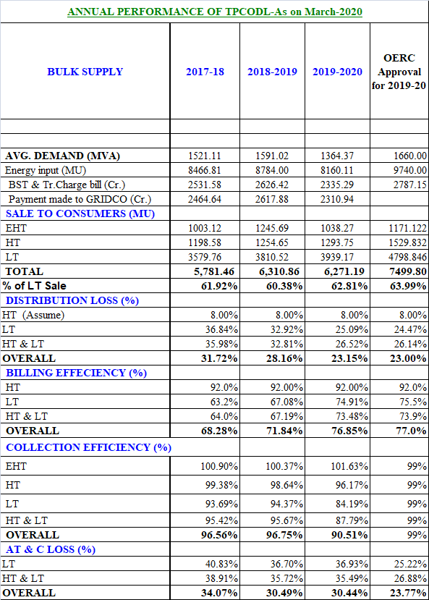

Commission’s Observations:
The. CEO, TPCODL apprised the Commission about the performance made by TPCODL during FY 2019-20.
The Commission compared the figures relating to business operation of TPCODL for FY 2019-20 with that of FY 2018-19. The key observations are as follows:-
 | As on 31.03.2019 | As on 31.03.2020 | Increase / Decrease | (↑↓)
EHT Sale (MU) | 1245.69 | 1038.27 | 207.42 | ↓
HT Sale (MU) | 1254.65 | 1293.75 | 39.1 | ↑
LT Sale (MU) | 3810.52 | 3939.17 | 128.65 | ↑
Distribution Loss | 28.16% | 23.15% | 5.01 | ↓
Billing Efficiency | 71.84% | 76.85% | 5.01 | ↑
Collection Efficiency | 96.75% | 90.51% | 6.24 | ↓
AT & C Loss | 30.49% | 30.44% | 0.05 | ↓

- From the above table it is observed that there is decrease of EHT sale of 207.42 MU, where as in HT & LT category the sale has increased by 39.1MU & 128.65 MU respectively.
- On Commission’s enquiry about the more than 200 MU reduction in EHT sale, TPCODL representatives stated that “ this reduction is due to 226 MU less consumption by M/s. Bhusan Steel compared to last year “. They also stated that BRG Iron & PPL have consumed less compared to last year.
- TPCODL submitted that 1,60,542 number of consumers have been added during the FY 2019-20.The total number of consumers as on 31.03.2020 is 26,92,946.
- On Energy Audit, TPCODL submitted that out of 182 nos. of 33 kV feeders, all 182 feeders are metered and 123 Nos. have been audited. Out of 974 nos. of 11 kV feeders, 873 nos. of 11 kV feeders have been metered. They have audited 682 nos. 11 kV feeders. Out of 71,240 nos. of DTRs, 8743 DTRs are metered and 1111 numbers of DTRs are audited.
- TPCODL had paid 11 months bill, i.e. it is lagging behind 1 month in BSP payment.

STATUS OF ARREAR FOR THE FY-2019-20 (In Rs Cr.)
Particular | Arrear as on 31.03.2019 (Rs. Cr.) | Billing for the 2019-20 (Apr-Mar) | Collection against arrear for the fy -2019-20 (Apr-Mar) | Arrear as on 31.03.2020
1 | 2 | 3 | 4 | 5=(2+3-4)
EHT | 106.50 | 665.00 | 675.82 | 95.69
HT | 43.84 | 816.85 | 785.58 | 75.11
LT | 1595.89 | 1898.54 | 1598.30 | 1896.13
Total of above | 1746.22 | 3380.40 | 3059.70 | 2066.92

- Metering Status:-
The Commission reviewed the progress in consumer metering. The representatives of PMU, OPTCL stated that out of 2,38,000 meters to be supplied by them, 2,13,015 meters are already installed in TPCODL area. TPCODL officials told that presently they have 45,000 meters with them in store. PMU, OPTCL has ordered another 18,413 meters for TPCODL.
- Commission has observed that LT realisation is better compared to overall realisation in all divisions of TPCODL. Commission enquired about correctness of reporting.
- Commission also observed that at Paradeep LT realisation is almost half of the overall realisation. Hence Paradeep LT performance is one major areas of concern.
- Commission expressed displeasure over the reduction in collection efficiency compared to previous year. The TPCODL representatives stated that the reduction in Collection efficiency is due to COVID-19in last quarter and Cyclone FANI in first quarter of FY 2019-20.

Directives of the Commission:

- The Commission directed C.E..O, TPCODL to check whether only defective meters are replaced by M/s. Linkwell or ok meters are also got replaced.
- The Commission directed TPCODL official to submit the report on DTR burnt at NEDN & PED division since both the divisions have high DTR burnt as well as capacity of burnt DTR.
- The Commission directed TPCODL to improve both Billing & Collection as both are not par with expectation.
- The Commission asked TPCODL to go for realistic assessment of the HT loss which actually not 8%
****

