ODISHA ELECTRICITY REGULATORY COMMISSION

PLOT NO. 4, CHUNOKOLI,SAILASHREE VIHAR

BHUBANESWAR - 751 021
************

No.DIR (T)-368/09/18/

Dated- .07.2020

To
Dist. Sambalpur.
The Authorised Officer,
WESCO Utility, At/P.O. Burla,

Sub: Review of Annual Performance of WESCO Utility FY 2019-20 (April-March)

Sir,
In inviting a reference to the subject cited above, I am directed to send herewith the aforesaid report for your information and necessary action.

Yours faithfully,

Encl: As above.

SECRETARY

Copy to:
- The Principal Secretary, Department of Energy, Govt. of Odisha along with copy of the enclosure for favour of information.
- The MD, OPTCL, Janpath, Bhubaneswar along with copy of the enclosure for favour of information.

Encl: As above.

SECRETARY

Record Note of Annual Performance Review of WECSO Utility held on 26.06.2020 at 03:00PM through video-conferencing in the presence of the Commission

Date of Review : 26th June, 2020
Period of Review : April 2019-March 2020
Representatives of WESCO :
The performance of WESCO utility for FY 2019-20 was reviewed by the Commission on 26th June, 2020 at 03:00 PM through video conferencing, keeping in view the current pandemic (Covid-19) situation. The senior officials of WESCO utility were present during the review.
The details of performance of WESCO utility as indicated in their presentation with regard to the key performance indicators are as follows:-
ANNUAL PERFORMANCE OF WESCO-As on March-2020
BULK SUPPLY | 2017-18 | 2018-19 | 2019-20 | OERC Approval for 2019-20
AVG. DEMAND (MVA) | 1869.00 | 1383.00 | 1239.00 | 1350.000
Energy input (MU) | 7248.22 | 7573.27 | 7523.90 | 7750.00
BST & Tr.Charge bill (Cr.) | 2378.98 | 2421.45 | 2461.33 | 2550.95
SALE TO CONSUMERS (MU)
EHT | 1219.19 | 1556.92 | 1580.23 | 1300.00
HT | 1682.44 | 1808.75 | 1929.55 | 1756.31
LT | 2476.46 | 2606.64 | 2604.74 | 3174.69
TOTAL | 5,378.09 | 5,972.31 | 6,114.52 | 6,231.00
% of LT Sale | 46.05% | 43.65% | 42.60% | 50.95%
DISTRIBUTION LOSS (%)
HT (Assume) | 8.00% | 8.00% | 8.00% | 8.00%
LT | 35.91% | 30.05% | 26.39% | 24.01%
HT & LT | 31.02% | 26.61% | 23.71% | 23.55%
OVERALL | 25.80% | 21.14% | 18.73% | 19.60%
BILLING EFFECIENCY (%)
HT | 92.0% | 92.0% | 92.0% | 92.00%
LT | 64.1% | 70.0% | 73.6% | 75.99%
HT & LT | 69.0% | 73.4% | 76.3% | 76.4%
OVERALL | 74.2% | 78.9% | 81.3% | 80.40%
COLLECTION EFFICIENCY (%)
EHT | 101.13% | 91.88% | 104.83% | 99.00%
HT | 100.34% | 100.39% | 99.08% | 99.00%
LT | 70.91% | 66.33% | 60.48% | 99.00%
HT & LT | 85.24% | 83.36% | 79.67% | 99.00%
OVERALL | 89.99% | 86.30% | 87.91% | 99.00%
AT & C LOSS (%)
LT | 54.56% | 53.60% | 55.48% | 24.77%
HT & LT | 41.20% | 38.82% | 39.22% | 24.31%
OVERALL | 33.23% | 31.94% | 28.56% | 20.40%

Commission’s Observations:
The. AO, WESCO Utility apprised the Commission about the performance made by WESCO Utility during FY 2019-20.
The Commission compared the figures relating to business operation of WESCO Utility for FY 2019-20 with that of FY 2018-19. The key observations are as follows:-
 | As on 31.03.2019 | As on 31.03.2020 | Increase / Decrease | (↑↓)
EHT Sale (MU) | 1556.92 | 1580.23 | 23.31 | ↑
HT Sale (MU) | 1808.75 | 1929.55 | 120.8 | ↑
LT Sale (MU) | 2606.64 | 2604.74 | 1.9 | ↓
Distribution Loss | 21.14 | 18.73 | 2.41 | ↓
Billing Efficiency | 78.9 | 81.3 | 2.4 | ↑
Collection Efficiency | 86.30 | 87.91 | 1.61 | ↑
AT & C Loss | 31.94 | 28.56 | 3.38 | ↓

- From the above table it is observed that there is decrease in LT sale by 2 MU, where as in HT & EHT sale has increased by 120.8MU & 23.31MU respectively.
- WESCO utility submitted that 1,07,139 number of consumers have been added during the FY 2019-20.The total number of consumers as on 31.03.2020 is 19,63,713and all consumers are given service connection. 50,000 nos. consumers are yet to bring under billing fold of WESCO Utility.
- On Energy Audit, WESCO utility submitted that out of 148 nos. of 33 kV feeders, all 148 feeders are metered and 118 Nos. have been audited. Out of 970 nos. of 11 kV feeders all 930 nos. of 11 kV feeders have been metered. They have audited 462 nos. 11 kV feeders. Out of 62,516 nos. of DTRs, 5993 DTRs are metered and only 699 numbers of DTRs are audited.
- WESCO utility had cleared all BSP bills 100%.

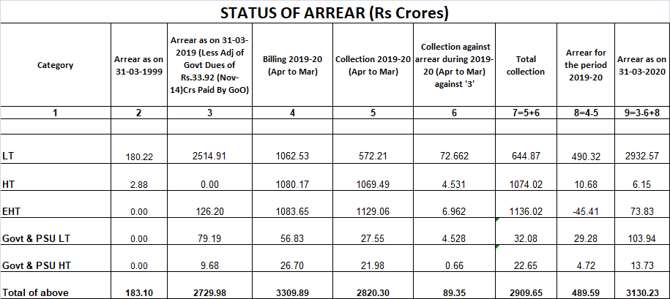

- Metering Status:-
The Commission reviewed the progress in consumer metering. The representatives of PMU, OPTCL stated that out of 6,60,000 meters to be supplied by them, 5,10,152 meters are already installed in WESCO utility area and only 1,49,848 meters are left to be installed. OPTCL has procured additional 87,000 meters for WESCO Utility and will install the same. Out of 1,49,848 meters left to be installed in WESCO Utility, 1,08,490 meters will be installed by Linkwell and 41,358 meters will be installed by WESCO Utility. OPTCL has also ordered additional 25,000 meters for WESCO Utility and it will complete meter installation by December 2020.
- Out of 32,325 numbers of LT 3-phase AMR to be installed, only 14,921 numbers of meters are
installed till March 2020. Out of 931 numbers of HT AMR to be installed, only 898 numbers are installed and out of 33 EHT AMRs only 12 numbers AMR are installed.
- Commission enquired about the increase in both DTR burnt and capacity of DTR burnt, specifically in urban areas.
- Though there is reduction in T & D loss of 5 pilot feeders , the reduction is not remarkable. It requires close monitoring.

Directives of the Commission:

- Commission directed WESCO Utility to improve billing and to go for monthly Billing.
- The Commission directed A.O., WESCO Utility to take action to reduce burning of distribution transformer.
- The Commission directed officials of WESCO Utility to reduce the losses of Pilot feeders.
- All Pilot feeders should be 100% metered.
****

