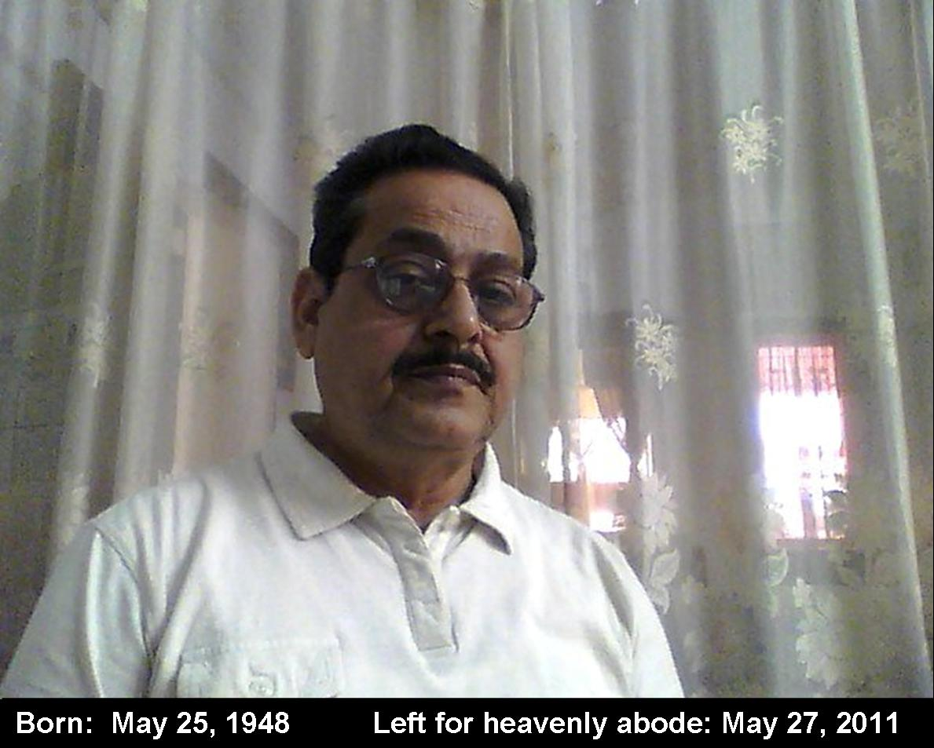

We, the members of the OERC family deeply mourn the sad and untimely demise of our ex-colleague, Late Er. Deena Krishna Satapathy on 27th May, 2011 at 9 P.M. in Bangalore. We recall our long and cherished association with him and express our deepest and heartfelt condolences to his family members and share their grief and sorrow.

After passing B.Sc.(Engg.) from UCE, Burla in 1969, Shri Satapathy joined Govt. of Odisha as Asst. Engineer and was posted in Joda and later in Balimela Power House. In 1982, he joined OSEB and opted for TTPS cadre. He has left an indelible image in the minds of people wherever he has worked and stayed. In 1995, he was chosen as an elite member of the PSRP (Power Sector Reform Project), the first such project in the power sector of India. He was then selected as the Joint Director(Engg.) of the first Electricity Regulatory Commission of the country, OERC in 1997. During his tenure at OERC, he has immensely contributed to Indian Power Sector at large and Orissa Power Sector in particular by framing numerous Regulations which prepared the framework for regulatory regime in power sector. Moreover, these regulations have stood the test of time and have helped other Commissions to frame their own. As rightly remarked by Shri P.K. Swain, Secretary of OERC, Shri Satapathy would be remembered as the “Ambedkar” of OERC. He also served as Ombudsman(Electricity) of Odisha from January 2008 to January 2011 during which he has delivered many landmark judgements.

He is survived by his wife, two sons with their wives and kids. In this hour of great sadness, we pray Lord Jagannath to bestow his family members with courage and blessings to withstand such an irreparable loss. We pray for his soul to reach the heavenly abode and rest in peace.

